CUB SCOUT

PACK



Alameda Church of Christ
Parent Guide
2012-13

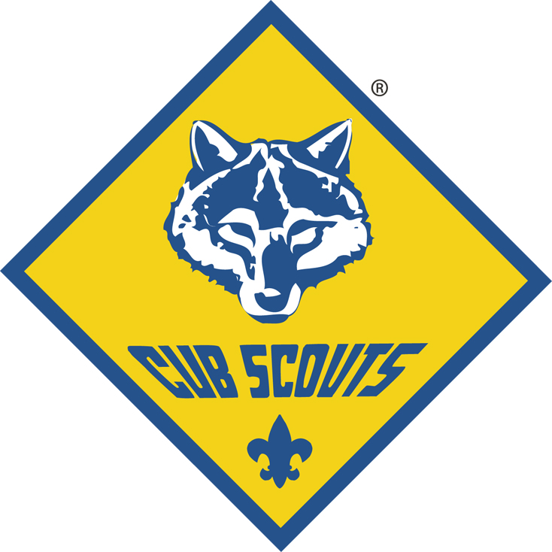

Thanks to Adam Peterson Pack 231

CUB Scouting: What is it?
Since 1930, the Boy Scouts of America (BSA) has helped younger boys through Cub Scouting. It is a year-round family program designed for boys who are in the first through fifth grades. Parents, leaders, and organizations work together to achieve the purposes of Cub Scouting. Currently, Cub Scouting is the largest of the BSA’s three membership divisions (the others are Boy Scouting and Venturing).
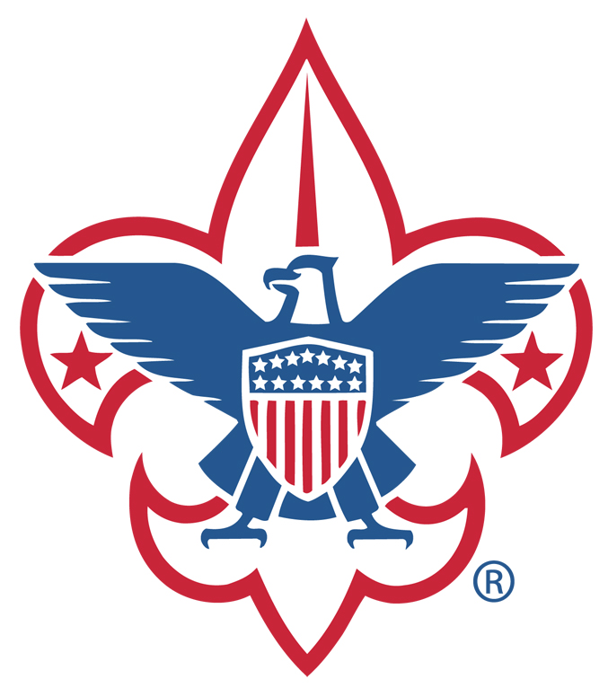
The Scouting program is an educational experience concerned with values. In 1910, the first activities for Scouts were designed to build character, physical fitness, practical skills, and service. These elements were part of the original Cub Scout program and continue to be part of Cub Scouting today.
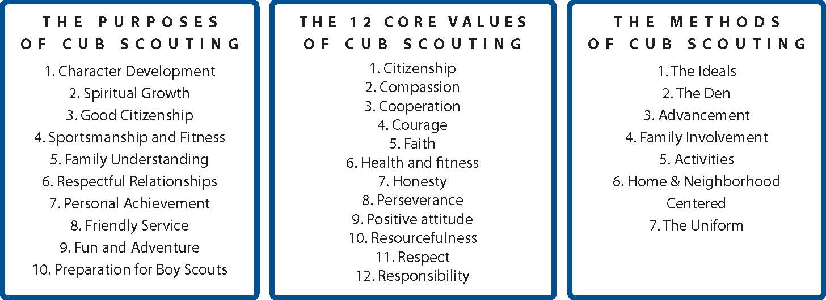In Pack 777 we believe that Cub Scouting is fun, but it is fun with a purpose. This guide contains information to help you understand how Pack 777 practices Cub Scouting.

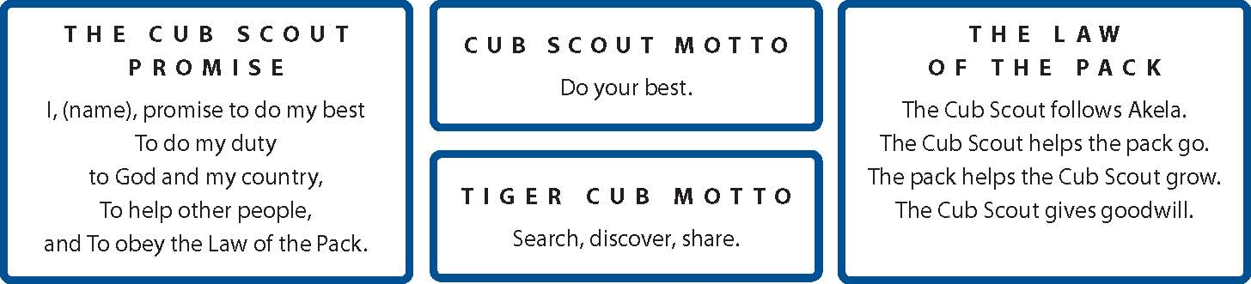Apart from the fun and excitement of Cub Scouting activities, the Cub Scout Promise, the Law of the Pack, the Cub Scout sign, motto, handshake, and salute all teach good citizenship and contribute to a boy’s sense of belonging.

THE CUB SCOUT PROGRAM
As a concerned parent, you want your son to grow up to be a person of strong self-worth, self-reliant, dependable, and a caring individual. Scouting has these goals in mind for him. Since 1910, Scouting has been weaving lifetime values into fun and educational activities. Scouting reinforces your efforts at home by strengthening character, promoting good citizenship, and encouraging physical fitness. The values instilled by Scouting will help your son make good decisions throughout his lifetime and give him the confidence he needs in a morally challenging world.
With all the negative influences in today’s society, Scouting is a positive beacon that emphases “doing right” and “doing good.” Our Dens and Pack will provide your son with a positive peer group, and a program that is fun and adventurous. The Cub Scout Motto is “Do Your Best,” and the Boy Scout Motto is “Be Prepared.” Could there be any better watchwords to guide your son as he matures into an adult?
1st Grade: TIGER CUBS
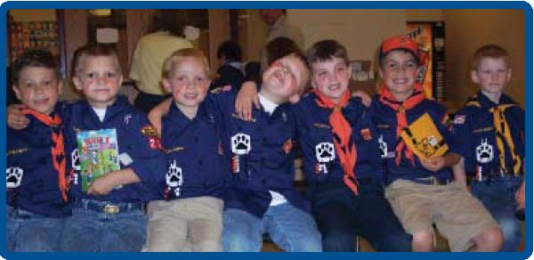
The Tiger Cub program introduces 1st grade boys and their parents to Cub Scouting. Each boy participates with a parent (or another adult family member) in family-oriented activities and outings. Parents assist the Tiger Cub Den leader in planning and holding meetings and activities. The time you spend together is meant to be fun, a chance to get to know one another better, and do things with your family and a peer group of families like yours.

2nd Grade: WOLF CUBS
Based on Kipling’s Jungle Book story of Mowgli (the man cub) and the Wolf Pack, Wolf Cubs learn to be resourceful and to do “Their Best”, while following the Wolf Trail. Gold and Silver Arrow Points are earned for extra achievements. Skits, games, field trips, service projects and outdoor activities help fulfill a boy’s desire for adventure and allow him to use his vivid imagination.

3rd Grade: BEAR CUBS
As in the Wolf Cub program, the Bear program is based on the Jungle Book story. Advancement activities are at a more advanced level but include all the adventurous activities Wolves get to do and more. The Bear Cub program, like the others, is carefully designed so that the things they are asked to do are appropriate to their age so they are still being challenged yet still having fun.

4th & 5th Grade: WEBELOS I & II
Webelos is short for WE’ll BE LOyal Scouts. The focus is on getting your son ready for Boy Scouts. The requirements for advancement in the Webelos program are more specific and detailed than required of Tiger, Wolf and Bear Cubs. The nature of the achievement work is similar to what Boy Scouts do. Webelos also learn what they need to know to earn the rank of Scout in Boy Scouts. Webelos can camp with a Boy Scout Troop at the fall Camporee. 1st and 2nd year Webelos go to a two night camping trip at a Boy Scout camp.

BOY SCOUTS
A program designed for boys in grades six through twelve with focus on building self-esteem, self-reliance and personal growth through a blend of outdoor experiences, educational and instructional skills, recognition, value building, and fun.
MISSION: The mission of the Boy Scouts of America is to prepare young people to make ethical and moral choices over their lifetimes by instilling in them the values of the Scout Oath and Law.
VISION: The Boy Scouts of America is the nation’s foremost youth program of character development and values-based leadership training.

THE ADVANCEMENT PLAN
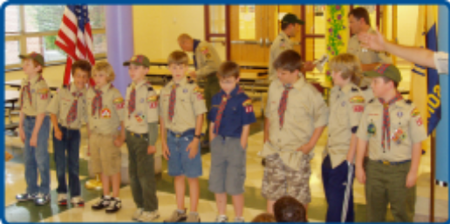
Recognition is important to young boys. Cub Scouting has an exciting advancement plan made up of badges, belt loops, pins, and awards that provide a fun way for boys to gain a sense of personal achievement.
The responsibility of a boy’s advancement in Cub Scouting lies with the family and not with the Pack. Some advancement requirements are done at den meetings but most are done at home with the family.
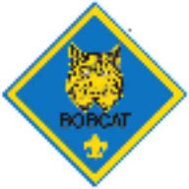

BOBCAT
All Cub Scouts must first earn the Bobcat badge by learning the basic tenets of Cub Scouting, including the Cub Scout Promise, Law of the Pack, handshake, salute, sign, motto, and meaning of “Webelos.” After receiving the Bobcat badge, a scout may work on requirements based on his grade level.


TIGER
The Tiger Cub badge is earned after completing five achievements grouped in three areas: den activity, family activity, and Go See It. After completing the Tiger Cub rank, boys may earn one Tiger Track bead when he completes 10 electives. There is no limit to the number of Tiger Cub beads a boy can earn. Advancements are displayed on a Tiger Cub Immediate Recognition Emblem, which is worn on the scout’s shirt pocket.


WOLF
Wolf Cubs must complete 12 “tracks” or achievements to earn the Wolf badge. They work at home and in the den to earn beads as evidence that they are “progressing toward rank. “ After earning the Wolf badge, scouts may work on electives in different interest areas until he is old enough to begin work on the next rank. For every 10 electives a boy completes, he earns an Arrow Point. A boy may earn as many Arrow Points as he can.


BEAR

Bears must also complete 12 tracks, but are able to select from 24 tracks. These achievements are categorized into God, Country, Family, and Self. They receive progress toward rank beads and earn arrow points once they are awarded the Bear badge.
Both Wolf and Bear Cubs can earn Arrow points.


WEBELOS
The Webelos program prepares boys for the transition into Boy Scouts. They earn activity badge pins in up to 20 activity areas that introduce them to a myriad of career possibilities. More independence is evidenced as the boys complete most of their activities in the den setting. Besides the Webelos badge, Webelos can earn the Arrow of Light badge which is the highest award in Cub Scouting and is one of two patches a scout can continue to wear on their uniform as a scout. The other patch is the Religious Knot.

Camping and outdoor programs are an important part of the 18 month Webelos program. In February of a Webelos Scout’s 5th grade year, he graduates from Cub Scouting into the adventure of Boy Scouting at an impressive graduation ceremony often referred to as “Crossover”.

SPECIAL PROGRAMS AND ACTIVITIES
Cub Scouts is all about participating and doing your best, and is designed to keep boys active and motivated. Additional activities are organized by Pack 777 to achieve the purposes of Cub Scouting (and of course, to have FUN). Some of these activities may include:
Family Camp Outs (fall and spring)
A joint family campout combines Pack 777 with Troop 777 and is a great way to ease into camping for newcomers, yet it is packed with fun and scouting activities for the whole Pack.
Scouting for Food (Fall food drive)
This is an annual Good Turn project to collect food for charitable organizations where both the Pack and the Troop collections are used by the charter sponsor, Alameda Church of Christ for the holiday food baskets.
Weed and Bleed (fall and spring)
A Pack and Troop 777 tradition has the Pack and Troop again working together during this joint service project. Held at the Alameda Church of Christ, the scouts work together to clean the church grounds of weeds, limbs and trash. A blood drive is also held during this time for the adults to donate to the local blood bank.
Rain Gutter Regatta / Pinewood Derby (fall/winter)
Parents and scouts work together to build a scout wind powered boat and then gravity powered miniature racecar. Dens race for champions and those winners compete for Pack Champion honors.
Garage Sale (spring)
This is an annual fund-raiser and good place to pick up camping gear. Proceeds go into the scout accounts of the boys.
Blue and Gold Banquet (spring)
This is a banquet and celebration for Cub Scouting’s Birthday which also can serve as a graduation ceremony for Webelos to Boy Scouts.
Camp-ins (various times)
Participation in the Oklahoma Science Museum camp in has been fun for the boys and allows for scouts to work on rank related crafts and activities.
Community Activities and Events
Norman Winter Holiday Parade
Family Picnic (summer)
Day Camp and Resident Camp (summer)
A scout has the opportunity to participate in summer camps. Tigers and Wolves traditionally participate in a week long Summer Camp at John Nichols Scout Ranch, where the boys arrive in the morning and leave for home that afternoon. The Bears and Webelos have attended Resident Camp where the boys spend 4 days/ 3 nights at Camp George Thomas. These camps have been in the past held sometime during the month of June.

FUND RAISING
Pack 777 participates in two major fund raising activities, popcorn sales in the fall and mulch sales in the spring. There is also a garage sale in the spring. A percentage of the profits from popcorn benefit BSA and the local council to help with things such as maintaining the local campgrounds. Of the remaining profits, a portion goes to the pack to help pay for merit badges, achievements and awards for the boys. The largest percentage of profits goes into a personal account assigned to the scout and can be used to pay for camps, camping equipment, recharter (renewal of scout registration) or any other scout related activities.

SERVICE PROJECTS
The Cub Scout Promise states a Cub Scout has a duty “to help other people”. The Law of the Pack states, “The Cub Scout gives goodwill”. What better way than through service to our community. Pack 777 is active in service projects, as we believe service promotes citizenship and respect for our community.

WHO LEADS CUB SCOUTS?
YOU DO! Cub Scout leaders are fathers, mothers, older siblings, grandparents, and other family members of boys involved in the Cub Scout program. Family members have the opportunity to volunteer in a variety of roles within the Pack. It is very important for you, as a parent, to be involved in some capacity. “Service” underlies the scouting movement. To “Help the Pack Go” and “Help the Pack Grow”, we need the assistance of parents who are willing to either join Pack leadership or take responsibility for a special event.

HOW CAN YOU HELP?
Scouting operates through volunteer leadership. Volunteer leaders are an example of Scouting’s principle of service to others. Naturally, parents are the primary source of leaders in the Scouting program. You volunteer not only to serve Scouting, but also to help your son and his friends, and to have the chance to be a positive influence on the youth in your community.

WHAT DO YOU GET IN RETURN?
Being a leader is fun, challenging and rewarding. Leaders find that their experiences help them to become better parents. The following are some of the many dividends that will enrich your life as you dedicate your time, talents and enthusiasm to Scouting:
- Fun and fellowship with other families, sharing your pride in the boys’ accomplishments.
- The privilege of helping to enrich and strengthen families.
- A chance to help boys learn good citizenship and to help shape them into men who have strength of character and are sensitive to the needs of others.
- The opportunity to help make a difference in the lives of boys, as they grow strong in mind and body. A code to live by which will set a worthwhile example for both boys and adults.
- The satisfaction of being a member of a worldwide movement, and pride in being publicly identified, as part of this organization—wearing the Scouting uniform is a visible means of showing you believe in and stand up for the ideals and objectives of the Boy Scouts of America.

PACK VOLUNTEER LEADERSHIP
Listed below are Pack leadership roles with short descriptions of each.
Den Leader: Leads the den at monthly Den, Pack meetings and outings. Attends monthly Committee meetings.
Asst. Den Leader: Assists Den Leader with Den meeting programming.
Cubmaster: Helps plan and carry out the pack program with the help of the committee. Emcees Pack meetings.
Asst. Cubmaster: Assists Cubmaster in developing Pack programming, and Pack meeting organization.
Committee Chairperson: Presides at all Pack committee meetings.
Secretary: Keeps notes on business conducted at Committee meetings and handles all Pack correspondence.
Treasurer: Oversees Pack finances.
Advancement Chair: Maintains advancement records for the Pack. Orders and obtains all badges, awards, and other insignia.
Training Chair (Pack Trainer): Promotes leader training and Roundtable meeting attendance.
Tiger Coordinator or Coach: Assists new Tiger leaders in getting started with programming.
Camping Chair: Oversees the organization of and secures volunteers to assist with Pack camping programs.
Programs/Activities Chair: Oversees the organization of and secures volunteers to chair and assist with Pack activities and programs.
Special Programs Committees/Parent Helpers: Work with the Pack Committee and subcommittees as needed to carry out Pack programming.

THE ORGANIZATION

The DENS
A Den is a group of six or more boys and meets twice or three times a month for an hour. Dens are led by a Den Leader (a parent) and helped by one or more Assistant Den Leaders who are also parents. Some Dens elect a boy leader (called a Denner) who carries out specific tasks at Den meetings. Some Dens are able to obtain the services of a Boy Scout who serves as a Den Chief. The weekly Den programs are designed around monthly themes supported by “Program Helps”, Scouting Magazine, Pack Committee Meetings, Council-sponsored leader meetings (Roundtables), and leader manuals (The Big Idea Book and Ethics in Action).

The PACK
The Pack is made up of several Dens and meets once a month. All Cub Scouts and their families are invited to attend. The Cubmaster and an Assistant Cubmaster run the Pack meeting. It is the climax of the month’s Den meetings and activities. The Pack meeting program may include games, skits, stunts, ceremonies, songs, presentations, and achievement recognition.

The PARENTS
The key to a successful Scouting program is parental involvement. Scouting is about all the things we’ve talked about, but at its core is helping you find new avenues to relate to your son and participate in your son’s growth. Please commit yourself to talking to your son about the requirements of his rank and how he can work on them with your guidance. You will likely find your son anxious to work together with you on these achievements. Cub Scouts is one way you can develop a bond with your son that enables open and honest discussions. Maybe this type of relationship will help in the often-difficult years of adolescence, which lie ahead.
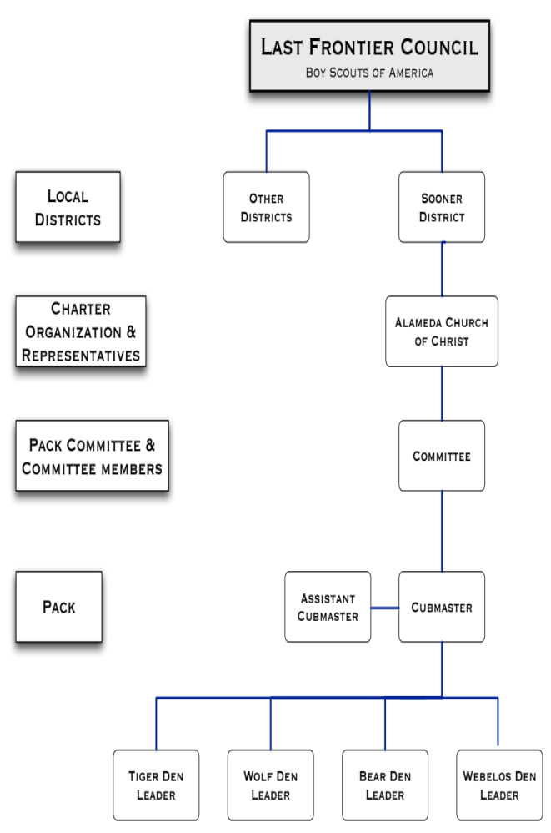
The Pack program is heavily dependent on parent volunteers. Many parents are involved in leading Dens and that activity requires planning, preparation, and implementation. Any help a parent can give a den leader makes a big difference. Additionally we need parents who are not already involved as leaders who can manage or assist with special event committees and projects for the Pack. All active parents and Scout leaders must complete and be Youth Protection Trained.

The PACK COMMITTEE
The Pack Committee is made up of all leaders (Committee Chairperson, Cubmaster, Assistant Cubmaster, Den Leaders, etc.) and is led by the Committee Chair. The committee meets every other month (or as needed) to plan Pack meetings, activities, and perform other Pack related duties. Parents are welcome to participate in these meetings.

The CHARTER ORGANIZATION
The Pack is owned by the Chartered Organization, in our case, the Alameda Church of Christ. This organization functions as our sponsor, and also provides a place for the Pack to meet. A Charter Organization representative serves as a liaison to the Pack.

The COUNCIL
Last Frontier Council is our local BSA council and supports the work of the Pack with a fulltime District Executive, monthly organizational meetings, training programs for leaders, and District wide events such as the Tiger Cub Fun Day, and summer camp programs.

The Pack Organizational Chart
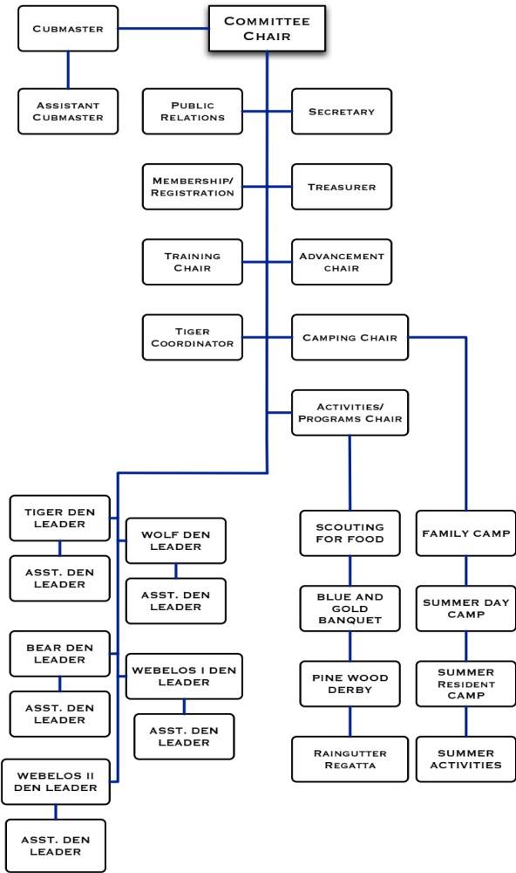
What Will My Scout Need?
You are responsible for:
Cub Scout Shirt: Tiger, Wolf and Bear Scouts wear the blue Cub Scout shirts. Webelos Scouts, at their option, may switch to the khaki shirt. (Many Scouts outgrow their shirts. At this point, it makes sense to switch to the khaki shirt that can be used in Boy Scouts). There are long and short sleeve shirts. Most people buy the short sleeve shirt and buy a long-sleeve thermal shirt for the winter to wear underneath.
Neckerchief Slide: You will need a neckerchief slide for your Cub Scout rank (Tigers may choose to purchase the Cub slide instead of the Tiger slide).
Patches: When purchasing the shirt, buy a Last Frontier Council Patch and the Pack numbers (7,7,7). A World Scouting Crest (round purple patch) is optional.
*A document describing the placement of patches on the Cub Scout uniform can be found online here: http://www.scouting.org/forms/. Additionally your den leader will be able to provide you with this information.
Belt, Trousers, Socks, & Shoes: These items are not mandatory for Pack 777, but are available if desired. Scouts typically wear plain blue jeans or pants (or shorts in the warm weather), socks, and sneakers. Many scouts purchase and wear a scout belt for belt loops that are awarded.

Where to buy:

Meinders Scout Shop: 3031 NW 64th, Oklahoma City, 405-840-1114 x258 or 1-888-841-1114 x258

Once your scout has been a member of Pack 777, the Pack will provide your scout with the following:
- A scouting book for each rank
- A neckerchief and slide for each rank
- Advancement patches and awards
- Instant Recognition Kits for Tiger and Progress Toward Rank Kits for Wolf/Bear

What Does It Cost?
Pack Registration: Our Pack charges $30 in Pack dues, $15 for BSA registration, $1 for BSA Insurance and an optional $12 for the scouting magazine, Boys Life.
Uniform and Books: $30 to $40
Special Events: Some Special Events have an additional cost.
Summer Camps: Typically $60 for Day camp and $110 for Resident Camp
Den Dues: Dens typically set a small fee or “den dues” to offset supplies and other costs associated with running a den.
Leaders: All leaders must complete the Adult Application form to become a registered adult and will be charged the $16 BSA registration and insurance fee. Parents are encouraged to register even if they do not plan on becoming leaders.
Scholarships: No one will be turned away because of financial need. Please fill out the forms which you can get from your den leader and talk to the Cub Master or Committee Chairperson.
The scout himself through his fundraising activities can cover many of these costs. Proceeds from the Scouting Popcorn sales and the mulch sales are deposited into a “scouting account” for the scout. The family’s receipts from scouting related purchases can be turned into the den leader who forwards them to the Pack Treasurer. Camp and other scout event fees can also be paid from the scout account.
Pack 777 has a scouting closet where there are uniforms that have been donated to the pack and are available for scouts.

Resources and Information
The amount of information and material on Scouting is vast. Below are some useful links that should be able to answer any further questions you may have about Cub Scouts. If not, please ask of the many leaders.

PACK 777 WEB SITE
We need help
Sooner District
soonerdistrict.org
LAST FRONTIER COUNCIL
www.lastfrontiercouncil.org
Scouter Mom
www.scoutermom.com

NATIONAL SCOUTING WEB SITE
scouting.org
Scout Parents
scoutparents.org
JOIN CUB SCOUTING
joinscoutingok.com
US Scouting Service Project
usscouts.org
Merit Badge
meritbadge.org

Contact Us!
Communication is key to the success of any organization. If you have any questions, comments, concerns, or ideas please do not hesitate to contact one of us at any time.

CUBMASTER
Fred Goodwin
fgoodwn@gmail.com
364-4455

COMMITTEE CHAIR
JoAnn Belknap
dmhg@swbell.net
360-3124
MEMBERSHIP CHAIR
Donna Goodwin
dmhg@swbell.net
364-4455

Notes

